**Reviewer's Access Guide**

1. The address to access the portal is <https://portal.icgi-ukdw.id/>.
2. This display will be located on the main page. To log in, click on the "Sign In" button in the upper right corner.



1. On the following screen, you will have the option to authenticate using your account credentials.

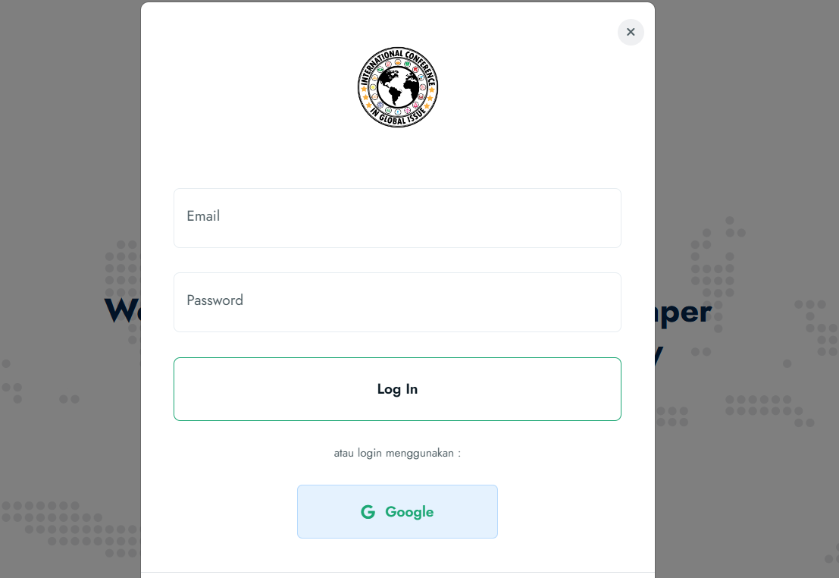

1. To alter your role to a Reviewer, please send an email to [icgi.research@staff.ukdw.ac.id](mailto:icgi.research@staff.ukdw.ac.id) for research or [icgi.comservice@staff.ukdw.ac.id](mailto:icgi.comservice@staff.ukdw.ac.id) for community service, and confirm to the committee.
2. Complete your personal information in the Profile Settings section after logging in (you are not required to modify your password if you prefer).
3. The subsequent action is to select the submission menu located on the left-hand side of the screen after you have updated your personal information.
4. The submission menu will display a list of articles that will be reviewed by the Reviewer.

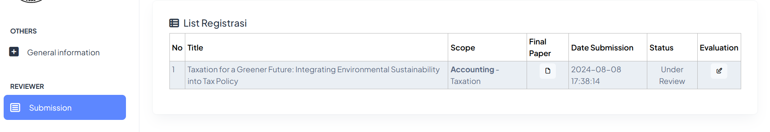

1. To initiate the evaluation of the paper, simply select the icon located in the Final Paper column.
2. You can input the assessment score according to the specified criteria and offer feedback to the author through the evaluation menu.
3. Within the evaluation option, you can input a score that falls within the range of 0 to 100.
4. By entering your feedback in the Reviewer Feedback column, you can provide feedback on the article you are currently assessing.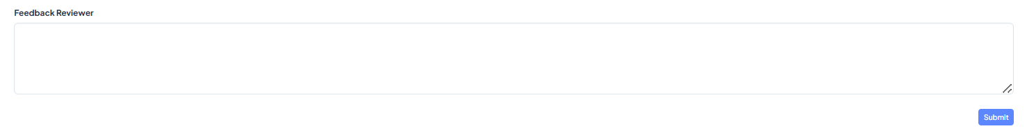
5. Upon completion, select "submit."